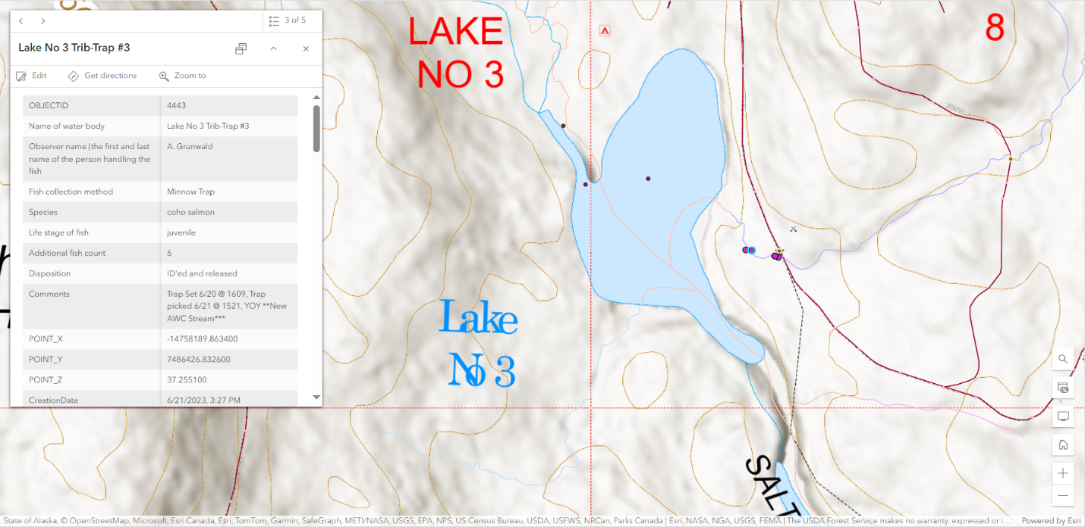

Figure . Area map of 7 CO juvs at upstream Fish Observation Pt (blue halo, Trap #3) on Lake Ellen No3 tributary 6/21/2023. The 2 Fish Observation Pts upstream (east) had DV, CT, Sculpin, but no CO.

Figure . Location map of 3 CO juvs at downstream Fish Observation Pt (blue halo, Trap #4) on Lake Ellen No3 tributary 6/21/2023.

Figure . Photo of CO juv Trap#3 the most upstream Fish Observation Pt.

|  |  |
| --- | --- |
| A hand holding a small fish  Description automatically generated  Figure . Photo of CO juv Trap #3. | A person holding a fish in a net  Description automatically generated  Figure Photo of CO juv Trap #3. |
| A fish in a net  Description automatically generated  Figure . Photo of CO juv Trap #3. | A fish in a net  Description automatically generated  Figure . Photo of CO juv Trap #3. |